Appendix 8

The Crosby Research Foundation
It’s amazing what you can find out from a simple Google search

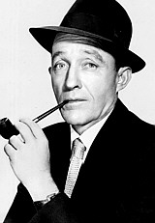
Who’s Crosby Research? Of course they were the 3rd party consultants that were contracted in May of 1973 to verify the outrageous Free-energy claims of E.V.Gray and his engine. They were paid by the Japanese mining and energy conglomerate Pan American Enterprises. The cover letter of the final 30 page report forms the keystone evidence as to the validity of this technology. In this letter the research director Mr. J.A. Maze describes how the equipment demonstrated a greater than 99% efficient operation. He then goes on to provide measurements that describe a calculated coefficient of performance (COP) of 275 at a power level of 7.6KW (10 HP). These tests and measurements were done at Cal-Tech in leased laboratory space with follow up measurements done at E.V.Gray’s shop in Van Nuys, CA.

O.K. so who is Crosby Research and why should we accept their analysis, especially since the original 30 page report has been lost?

Crosby Research Foundation was a very unique and specialized private company owned by the singer and actor Bing Crosby of “I’m dreaming of a White Christmas” fame. His very successful radio, TV, and movie career spanned well over 40 years and started in the early 30’s. He suddenly died in 1979 with a vast fortune in well operated businesses and the continuing royalties from songs and movies. But the story of this interesting side business is better told by biographers who have researched these events in detail.

By Deborah Dolan
Most Americans today have some awareness of Bing Crosby’s fame as a musical and film entertainer during the World War II era and perhaps even as a war bond promoter.
Even before war broke out, Bing Crosby had developed a reputation as an astute businessman. As early as 1940 he was awarded the U.S. Junior Chamber of Commerce distinguished Service key as a man under thirty-five years old who had contributed the most to his community during the previous year. How did Bing Crosby become involved in a business that would test over 15,000 inventions between 1941 and 1943?
John b. Rathnell, a motion picture writer and friend, had been a machine-gun officer and ordnance expert in World War I, When the War Department called him back to teach that subject to officers in late 1930s he advised Crosby that there would be an increasing need for entrepreneurs to develop new weapons, and suggested that Crosby go in to the research and development of such weapons. Bing Crosby and his brother Bob, also involved in the entertainment business, were well aware that fame and popularity could be fleeting, and that it was a good idea to have something else to fall back on. Thus Bing and his brothers Bob and Larry agreed to try the plan for a year and founded the Crosby Research Foundation in February of 1940 with the objective of testing, developing and marketing war and civilian use inventions, Rathnell later opened the office in Pasadena, California, in December 1940.
During the first year they looked only at ideas with military value and hired engineers to refine the items to the point of real potential value, with the idea that they would then bring those items to the attention of the government. This original plan, however, didn’t succeed, as the government labs were too busy with their own existing projects to take over the final development of these potential products. When they attempted to bring items directly to manufacturing outfits, they found that commercial ventures had put the bulk of their resources into the immediate production of war materials and were not interested in conducting further research and development. At this point, they changed their model and focused on finding inventions that could be made commercially viable for immediate production, items that were war goods but could be used in a post war civilian economy.
As mentioned earlier, the Crosby Research foundation tested over 15,000 inventions between 1941 and 1943, Some of those inventions included a radio-controlled “Iron pig” which loaded with TNT, could be forwarded to enemy emplacements; a lens that would enable pilots to see better in for; and a stereoscopic fluoroscope that would enable military surgeons to better view bullets, shrapnel, or severed nerves embedded in soldiers’ bodies, reducing the time in surgery. Some inventions, including a better tool for fastening plane cowlings to decrease vibration stress, and a device that would measure how much ice was on an aircraft’s wings, would also have postwar purposes, These items would then be farmed out to various manufacturers, who again, had halted or reduced their own research and development programs. Some inventions originally thought to be of military value were picked up by the government, but not to be used as they were originally intended. One such example was a “Molotov Bread-basket,” which was originally designed to scatter bomblets. While the military turned the idea down, the Department of Agriculture picked it up as a seed-scatterer to be used in humanitarian food efforts.¹

So, that’s how Crosby Research Foundation got its start. They were setup to seek out and evaluate the efforts of inventors from the very beginning. The short commentary above shows that at that time they already employed specialists in optics, mechanics, electronics, and aircraft design. Later on Mr. Crosby would buy into an aircraft factory to add to his list of investments. Consider how large of a staff would be needed to process 5,000 evaluations a year.

By the end of the War it appears that the Foundation was still going great guns. However this following article provides a little dose of practical reality into the nature of this business. This is something that Free-Energy researchers should be aware of, even though this took place in 1945 the market reality hasn’t changed that much.

Popular Mechanics December 1945
Of the 50,000 ideas and patents submitted since 1940 to the Crosby Research Foundation of Hollywood for possible marketing, less than on half of one percent had enough merit to warrant putting them on the market. Some were too visionary to be practical, some conflicted with patents already granted, others had too limited a potential market, still others would cost more to manufacture than he public would be willing to pay.
Organized as a business venture by Bing Crosby and his brother Larry, the foundation provides research, manufacturing, and marketing facilities for inventors who devise new appliances that stand a chance to become widely used. Inventions are not purchased by the foundation, but standard royalties are paid to inventors on the basis of sales volume.
During the war, the Crosby foundation helped develop the atomic bomb, a marine mine, and improved incendiary bomb and a device for detecting submarines. Right now the Crosby organization is readying patented articles for distribution at the rate of one new item per week.
Look what they are doing after being in business for only five years. In addition to the regular invention evaluation and marketing activities they are now selling their services as a consultant/vendor for specialized items needed in the production of the Atomic Bomb. This certainly wasn’t work they could bid on. Most likely the government needed an agile organization that could design prototype, develop, test, and manufacture sophisticated small runs of custom subsystems quickly and with high precession. I suspect the government came calling on them.

What ever Larry Crosby was doing in the management of this organization he apparently was able to attract employees who could “think-out-of –the box”. Out of the many specialties that the Crosby Foundation were exploring they soon became involved in advancing the early German technology of Reel-to-Reel tape recording in the United States. From there they devoted a large portion of their budget into initiating and then improving upon the multitude of techniques used in sound recording studios. Here is how it all started:

Enter Bing Crosby
On May 16, 1946, John Mullin was scheduled as the speaker at the regular meeting of the San Francisco chapter of the Institute of Radio Engineers, held at the studios of radio station KFRC. A demonstration of the German tape recording equipment had been promised, and the room was packed. Mullin played recordings of an orchestra, vocalists and a pipe organ that he had made on some of the tapes he brought back with him. The reaction was little short of a sensation.
One of those who heard about the demonstration was Frank Healy of Bing Crosby Enterprises. Healy believed that Mullin and his machines might provide the solution to a ticklish problem for the singer. In the 1940's, all programming, at least on the "prestige" networks (NBC, CBS and the fledgling ABC) was done live. Broadcasters and sponsors alike believed that transcribed shows -- those recorded in advance on 16-inch, 33 1/3 RPM discs -- sounded inferior and audiences would resent their "canned" quality. But Crosby, one of the highest-rated performers in the NBC stable, had insisted on freeing himself from the weekly grind of appearing live at the microphone. He sat out the 1945-46 season entirely, and came back only when third-ranked ABC promised to let him pre-record the Kraft Music Hall -- but only as long as the ratings remained high.
To Healy and Crosby's technical director, Murdo McKenzie, that meant recording bits of the show on a series of discs, then re-recording from one to another to produce a finished program. It was expensive, time-consuming, and worst of all, sounded bad -- particularly when one section had to be re-recorded two or three times.
Accordingly, one day in August, 1947, Mullin was called in to record the first Crosby show of the upcoming season on his German equipment, while Healy and McKenzie recorded it on disc. Mullin remembered the historic encounter:
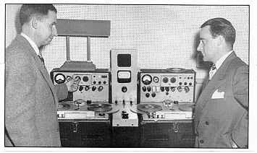
In this 1947 photo, Jack Mullin (left) shows his modified Magnetophone tape recorders to Murdo McKenzie, Bing Crosby's technical producer. Mullin's ability to edit on his high fidelity German recorders without noticeable generation loss created a sensation in American broadcasting. Mullin's machines later inspired the Ampex model 200. (Courtesy of Ampex.)
"The most unforgettable moment in my life was the one when I stood before my Magnetophone tape recorder and pressed the Playback button for the first time in the presence of Bing Crosby, John Scott Trotter, and Bing's producers, Bill Morrow and Murdo McKenzie. Everything was at stake. By invitation, I had been present with my colleague, Bill Palmer, to record the first radio show of the 1947-'48 season in the NBC/ABC studio complex in Hollywood. And now we were to hear the result of our efforts and be judged by perhaps the most critical ears in the world of radio and recording.
"Prior to our invitation to come to Hollywood from San Francisco to record, and possibly, just possibly, to edit our tape into a complete show, the producers had looked into every alternate means of recording sound that showed any promise of success. Mostly, these boiled down to variations of disc recording methods and photographic sound-on-film systems. I am sure ABC held out little hope for success in testing our apparatus.
"The result of the (very successful) demonstration was that the Crosby people wanted me to stay right there and go through an editing process, to make a broadcast out of it. I did," Mullin told a reporter, "and they saw how easy it was with tape. The next thing I knew, I had a job recording the Bing Crosby Show for the rest of the season."
The problem was that Mullin had only his two rebuilt German recorders and 50 reels of German recording tape for the task. Luckily for him, 3M was working on a commercial product with a backing of acetate film rather than paper.
Mullen also faced another problem -- the 3M tape was "too good" for the German machines, which couldn't handle the tape's higher coercivity. Wetzel and his associates went back to the lab to come up with a tape that would work on the old machines, and on the 12 audio recorders Ampex Corporation was rushing to complete for the American Broadcasting Company. Crosby had been instrumental in persuading the network to buy the machines, copied from Mullin's German originals.
It's worth noting that when the Kraft Music Hall aired on the night of October 1, 1947, it was broadcast from a 16" disc rather than from the tape Mullin had recorded in August. McKenzie and his crew, after having assembled the show from Mullin's master tape, put it on a disc for on-air playback. After one or two shows, they decided to gamble on broadcasting directly from the tape; but just in case the tape should break there was a musician standing by in a nearby studio ready to go on the air with a piano recital.
That practice persisted not only at network studios but also in the studios of larger stations around the country for a year or two, until broadcast engineers discovered that tape simply didn't break. Once ABC began to switch to tape, it made two copies of each program and started them simultaneously on playback decks. If one were to fail, the engineer had only to switch to the backup, missing hardly a syllable.^{3,4}
Once Bing Crosby heard what the early German tape recorders could do - all kinds of recording studio applications came to mind, and this was before the first recording studio ever existed. With money, reputation, and interest Bing directed his engineers to explore this new technology. He then found a small startup company; Ampex was attempting to bring to market some of the first tape recorders in the U.S. They got a huge boost when Bing bought in with the purchase of 50,000 shares, which was slightly less than a controlling interest. Mr. Crosby continued to maintained a close association with Ampex for the rest of his life.
With help from the Crosby Research Foundation the people at Ampex didn’t let any grass grow under their feet. Five months later they had their first production model ready for delivery and the Ampex 200 made history. This was the first operational professional tape recorder in the US.

Bing Crosby Enterprises then negotiated financing for Ampex for exclusive distribution rights and Mullin was employed to record the Crosby show on his original German equipment until the Ampex machines would become available. Mullin’s first recorded demonstration using the Ampex 200 was broadcast over ABC on October 1, 1947.

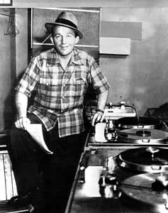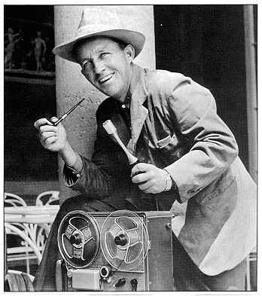
Bing Crosby with his beloved Ampex 200A recorders on left 1950, with Ampex 600 recorder on right in the early 50’s

AMPEX
MODEL 200A TAPE RECORDER (1948)
The story of the 200A—the first tape recorder from Ampex—is inextricably linked to the history of the German Magnetophon. After World War II, an engineer by the name of John Mullin brought two older Magnetophons back as war souvenirs, modified them for HF bias and demonstrated them to Bing Crosby, who used them to record, edit and play his weekly ABC radio shows. Helped in part by the U.S. government’s declaration that all German and Japanese patents were invalid, the decks were studied by the fledgling Ampex Corp., which launched its own recorder program.
The Ampex engineering team for the 200A included Harold Lindsay and Myron Stolaroff, who kept many of the Magnetophon’s basic features such as 30 ips operation and a B-wind design, in which the tape was wound with the oxide facing out. Unlike the portable Magnetophon, the Model 200A tape had a huge polished black wooden console and heavy anodized-aluminum fixtures and fittings. Recording one track across the full width of the 1⁄4-inch tape, the 200A was capable of performance that was flat within 0.5 dB from 30 Hz to 15 kHz.
In October 1947, the first 200A prototype was demo’ed at Radio Center in Hollywood; the enthusiasm by those who heard this wonder machine was apparent, and Ampex moved forward into regular production, with units serial #1 and #2 delivering in April 1948 in time to record and edit the 27th Bing Crosby show of the 1947-’48 season. A 200A retailed at $4,000—nearly as much as a house at that time—but the convenience of editing and the ability to time-delay performances appealed to Crosby, who no longer had to perform separate shows each week to reach different time zones. Weeks later, ABC ordered 12 more recorders and other broadcasters soon followed. In all, only 112 of the 200A recorders were made (the $1,500 model 300 followed it), but the impact of the benefits of tape-based production was felt throughout the world.
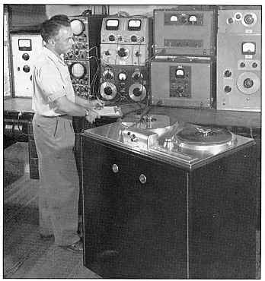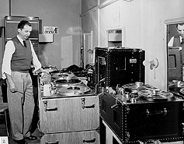
Ampex chief engineer Harold Lindsay (left) checks out the first American professional audiotape recorder, the model 200. This machine was first used by ABC in 1948. (Courtesy of Ampex.)
John T. "Jack" Mullin in 1950 with two "portable" Model 200 Ampex tape machines used to record ABC's Bing Crosby Show for radio.] (right)
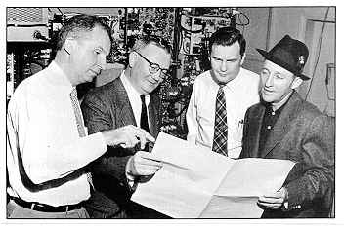
Magnetic recording tape pioneers Jack Mullin (left) and Frank Healey (with glasses) discuss early tape programs edited for the ABC Philco Hour radio program with Bing Crosby (right). Crosby was an avid proponent of tape recording, and his ABC network show was the first nationally broadcast tape program in the United States. (The fourth man in the photograph cannot be identified.) (Courtesy of 3M.)

The people at Crosby Research Foundation focused on development while the staff at Ampex paid attention to marketing, sales, manufacturing, service, and market research. Thus all of the patentable innovations were kept within the Crosby business empire. The sound recording team went on to develop multi-track machines, then the mixer electronics to manage the many channels needed to take the quality of recorded show productions to where they had never been before. They also sponsored the development of several promising microphone technologies. Three years later they made this countries first attempt at video recording.

November 24, 1951
The Billboard (an Entertainment Industry News Paper and Trade Journal)
“Der Bingle First to Use Newly Developed Visual Images System”
Hollywood – Bing Crosby will time his TV debut with the initial introduction of his firms’ sight-sound magnetic tape thereby becoming the first performer to use the newly developed system of recording visual images. His research engineers are working at top speed to have all the bugs out of the pix-sound taping device in time for Crosby’s’ telebow next fall.

This was the first attempt in the new medium. Ampex kept at it and five years later were just about ready to release a production video recorder

Videotape's big day was April 15, 1956, when the 31st annual convention of the National Association of Radio and Television Broadcasters (NAB) opened at the Conrad Hilton Hotel in Chicago. Ampex to showed its video recorder, the Mark IV (a forerunner of the production model, the VR-1000). 3M had supplied instrumentation tape as the recording medium.

O.K. this covers the roots of the Crosby Research Foundation up to 1956. What were they doing in 1973 when the Pan American Corporation came seeking verification of a Free Energy machine. They were now doing a lot of their own high level inventing in the very lucrative recording industry. They still were evaluating the work of inventor’s who willing to abide by their contract terms. Testing and the engineering review of a vast assortment of equipment was still their stock in trade. They had years of experience at it, a full legal department, and a number of staffed specialized leased laboratories all around LA. What they didn’t have on hand they knew where to get it. They also had developed a close relationship with the local prestigious universities in the area, especially Cal Tech. There was in place a working business arrangement where these universities would provide staff specialists and/or graduate students for part time assistance on a particular project on an open contract basis. This made knowledgeable consultants quickly available without the slow down of contractual fee negotiations.
So, when the Asian representatives of the Pan American Corporation inquired about their services the mention of a Free-Energy machine probably didn’t even rise an eyebrow. By then the staff at Crosby Research had probably evaluated a hundred or so similar submissions. As long as Pan American paid the bill they would receive a high quality, complete, impartial, and well documented analysis – regardless of how many physical laws it broke.
The point of these last few pages is to establish the degree of professionalism that was contracted to evaluate the E.V.Gray technology. This was no local three person TV repair shop. This was a large, professional cutting edge organization with numerous technical advancements to their own credit. They had the talent, the equipment, the knowledge, and the experience to find out just what this novel equipment could or couldn’t do and measure it within three decimal places of repeatable accuracy.
Keep this in mind as you read the next page as to what J.A. Maze reported to his boss Larry Crosby.
When Bing Crosby died in 1979 the Crosby Research Foundation (or Institute) was still a privately held company. As a result the company had to be liquidated as part of the final settlement of the Crosby Estate.
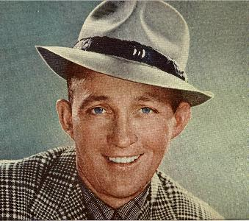

Bibliography
1. Not Just “The Crooner” Bing Crosby’s Research and Business endeavors in World War II by Deborah Dolan Chapter 12 from the book “Going My Way – Bing Crosby and American Culture” Edited by Ruth Prigozy and Walter Raubicheck University of Rochester Press Copyright 2007 Hofstra University

3. Mullin, John, "Discovering Magnetic Tape," Broadcast Engineering, Intertec Publishing, Overland Park, KS, May 1979.
4. Ziff, Richard, "Magnetic Tape's Impact on Broadcasting," Broadcast Engineering, Intertec Publishing, Overland Park, KS, May 1979.

Dr. Norm Chalfin and Dr. Gene Wester

It has been rumored that these two professionals took a serious interest in the E,V, Gray technology at the time it was being evaluated by Crosby Research at Cal Tech. It is unclear how they were associated with Cal Tech, JPL, and Crosby Research at the same time but some how they approach E.V. Gray and became board members.

The next page shows some of what is available on the Internet about these two gentlemen followed by a short article published in the “Tattler” written by Tom Valentine some time in 1973 of 1974. These men are academic professionals and appear well placed in their community. They certainly risked professional ridicule by even being associated with this Free-Energy venture, especially one that was being investigated for fraud.

Both men appeared to be still serving on the board at least until Jan 9, 1976. For such a serious interest to have developed they must have had first hand observations of the test data from the Crosby evaluation if not having been directly involved with that analysis.

The fact that not one, but two men of such academic stature came on board speaks volumes about how they perceived the power of this technology.

Dr. Chalfin holds a first class Radio amateur license, [K6PGX] thus he knows electronics from an application side as well as an academic theoretical position. The Tattler also discloses that Dr. Chalfin wrote the text for the Pulse Engine patent. In a recorded phone conversation Mr. Hackenberger claims that this was done for a fee and was in no way a donation.

Dr. Gene Wester is a power-electronics system engineer. He has developed high-performance power systems for space applications at the Jet Propulsion Laboratory. I would think he knew his business pretty well. It is highly unlikely that Gray could have pulled the wool over either of these two men. They knew what they were looking at. Despite their close association with Gray it is apparent that neither of them ever got enough of the complete technical picture to reproduce the technology – despite any secrecy agreements they were required to sign. It appears to this author, from reading the patent, that neither one of them were allowed to look under the hood of the EMA4, but were rather given some kind of explanation that sounded plausible. I suppose they were hoping to eventually be allowed to gain full access to the technology – which never happened.
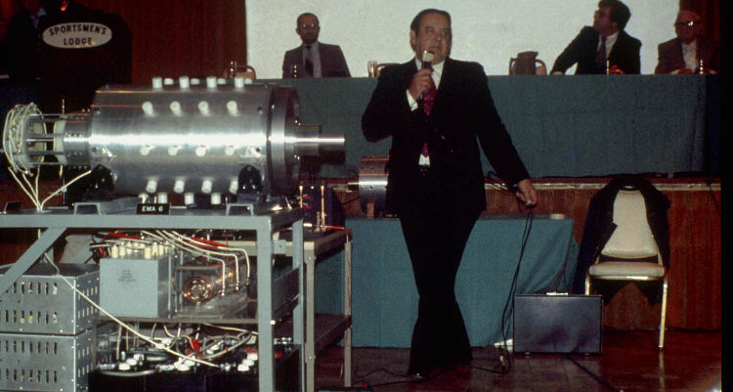

Dr. Gene Wester is sitting at the head table on the far left, Jan. 9 1976, photo by Tom Valentine
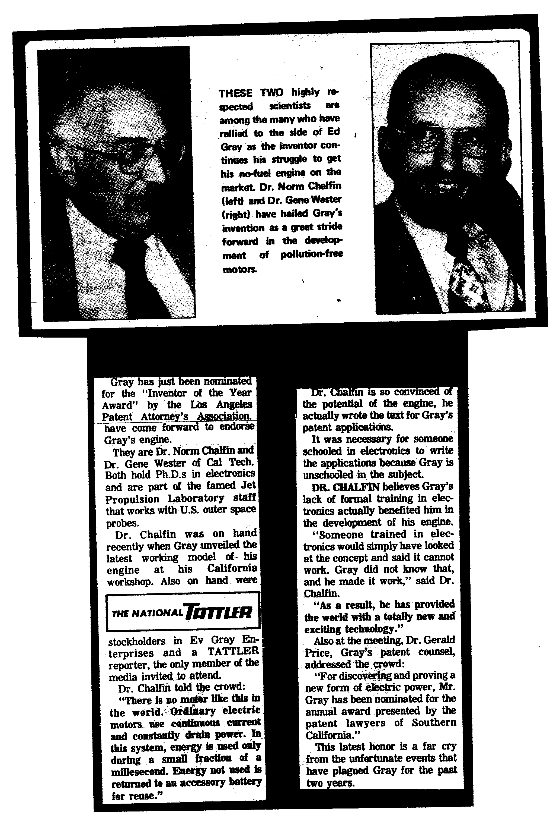
http://www.scvrs.org/newsltrs/body_nl9405.html

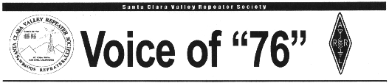
May 1994
NEWSLINE NEEDS OUR HELP
The weekly NewsLine service that many of us hear during the week, and which provides us with timely news of the Amateur Radio world, needs your financial support. It takes about $850 a month to support their service, and their piggy bank is getting empty. At this point they will only be able to operate through the end of April.
If you would like to help support them, you can send a donation to:
NewsLine Support Fund c/o Dr. Norm Chalfin, K6PGX P.O. Box 463 Pasadena, CA 91102

http://www.w6trw.com/crosstalk/July2004.pdf
July 2004,
Dr. Norm Chalfin K6GPX from JPL to Speak About OSCAR at next General meeting

PDF] Power System Electronics Development
File Format: PDF/Adobe Acrobat - View as HTML
Dr. Gene Wester is a power-electronics system engineer. He has developed
high-performance power systems for. space applications at the Jet Propulsion ...
trs-new.jpl.nasa.gov/dspace/ bitstream/2014/11667/1/02-0229.pdf - Similar pages

Keelynet - EVGRAY2.HTM - 02/24/00
Two highly respected scientists, Dr. Norm Chalfin and Dr. Gene Wester of California
Institute of Technology have publicly endorsed Gray's motor. ...
www.keelynet.com/evgray/evgray2.htm - 18k - Cached - Similar pages
[PDF] NEWSLETTER of the IEEE Power Electronics Society
File Format: PDF/Adobe Acrobat
ciety, Dr. Gene Wester will take over as its. Editor. Gene is no. stranger to
the So-. ciety, having been. an active partici-. pant over the years ...
www.ewh.ieee.org/soc/pels/pdf/vol11no3.pdf - Similar pages

